**MCA C LAB WORK**

**NAME - AJEET KUMAR**

**ROLL NO – 525110013**

**GROUP 1**

1. **Write a program to understand format specifiers (%c, %s, %d, %f, %0, %x, %6d, %6f, %6.2f, %.2f) for reading different types of variables.**

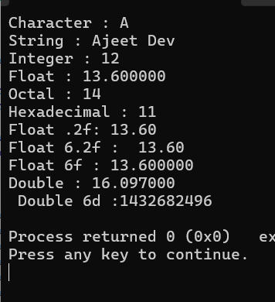

1. **Write a program for character input and output (use getchar() and Putchar()).**

**3. Write a program to read from keyboard and display on console (use printf() and scanf())**

**> string**

**\* integer**

**◆ character**

**◆ real value**

**double (large real value)**

**→ unsigned value of the integer**

**octal value of an integer**

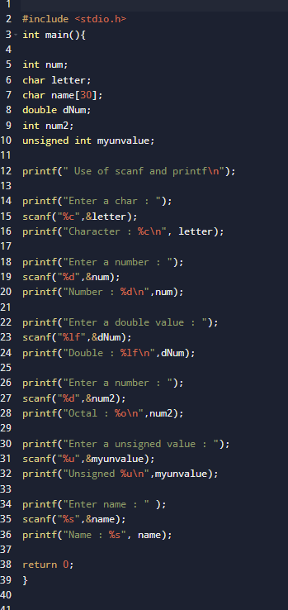

**4. Write a program to print different data types (int, float, char) with qualifiers (sort, long, long long, signed, and unsigned) using sizeof ().**

**5. Write a program to print the values of weekdays using enum data type.**

**6. Write a program to understand type conversion (implicit and explicit) concepts by performing addition and subtraction using int, float, and char data types.**

**7. Write a program to understand the shorthand or compound assignment operator (operand operator operand) concept using all arithmetic and bitwise operators.**

**8. Write a program to convert Fahrenheit to Celsius.**

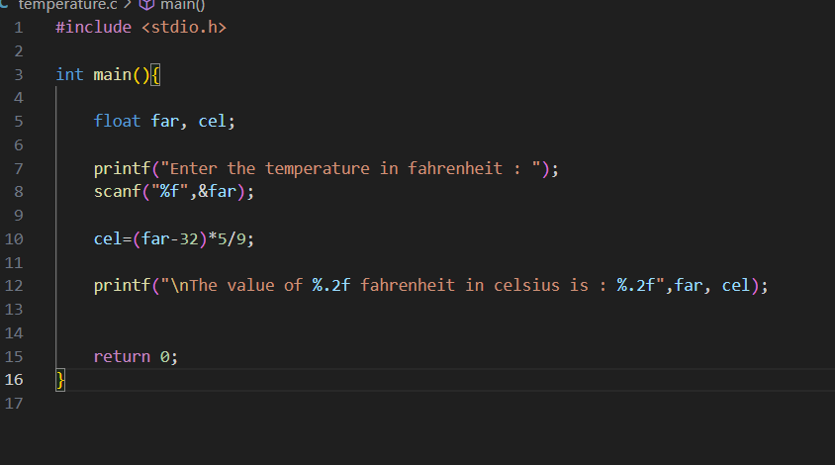

**9. Write a program to check whether a given number is even or odd using an if-else statement.**

**10. Write a program to find the largest number among given numbers using an if-else statement.**

**11. Write a program to make a simple calculator using a switch statement.**

**12. Write a program to calculate the sum of first n natural numbers.**

**13. Write a program to read input until the user enters a positive integer.**

**14. Write a program to check whether a given number is prime or not.**

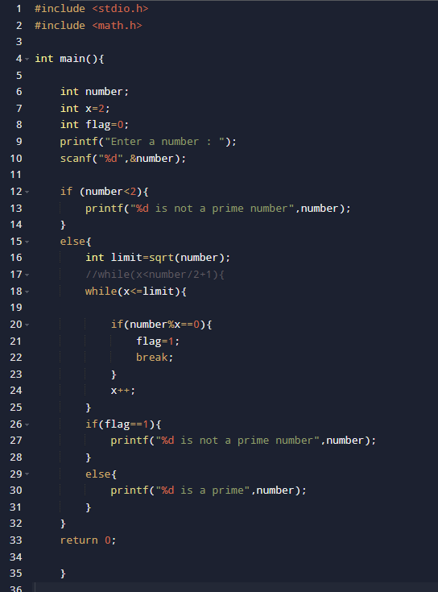



**15. Write a program to find the factorial of the given number.**